Dustin Qualley

November 13, 2019

Foundations of Programming: Python

Assignment06

**Python Script on Reading and Writing to Dictionary**

**Introduction**

In this document I will define and illustrate the use of functions in the Python language.

**Defining a Function**

Functions are a way of grouping one or more statements in Python. Functions must be defined prior to being called in the program. See Figure 1:

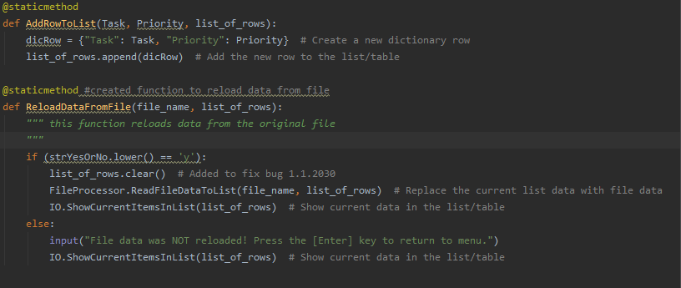

***Figure 1***

Here, two different functions are defined, “AddRowToList” and “ReloadDataFromFile.” Following the name of the function are parameters which allow the program to pass values into the function for processing. These values are called arguments. Headers can be added to functions using three quotation marks, as seen above as “this function reloads data from the original file.”

These functions are called later in the program when the user selects a choice from a menu of options. For instance, if the user selects “Option 2” which allows them to add a new item, Figure 2 shows the program getting user input, then calling the AddRowToList function.

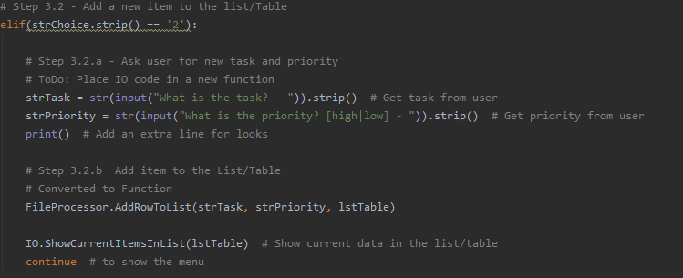

***Figure 2***

**Summary**

Functions allow for more efficient code writing and can make reading and working with code easier. Functions can work in a variety of ways including returning values or returning tuples.